Leverage EMR to Change Practice Patterns and Streamline Non-EMR Workflows - An Interfacility Transfer Process Improvement Effort with
Far Reaching Implications
Einas M. Batarseh, MD^{1,2}, Sashank Kaushik, MD, MBA, FAMIA^{1,2}
¹VA Western New York Healthcare System, Buffalo, NY; ²University at Buffalo, SUNY, NY

Introduction
Interfacility transfer (IFT) is an important strategy for improving access to specialized care for patients with complex clinical problems. IFTs account for roughly 3.5% of all hospital inpatient admissions annually (1.5 million admissions) nationwide, are inherently complex to coordinate and are recognized to be associated with increased risk of adverse events and mortality.(1, 2) Early in the process, after the decision to transfer is made, a written and informed consent from patient or healthcare proxy, a provider certification of reason(s) for transfer, and documentation evidence of warm handoff is mandatory before the transfer can proceed.⁽³⁾ Based on anecdotal reports of care delay, we decided to evaluate this segment of IFT as an Informatics-focused High Reliability Organization project.

Methods:
Multidisciplinary QI-team performed root cause analysis and investigated the impact of EHR navigational complexity on time to complete required steps and end-user usability barriers. We used LEAN methodology, PDSA, stakeholder analysis, and process flow mapping. The outcome measure was the time in seconds needed to locate correct orders, consults, and notes in the EHR. Primary PDSA cycles: 1) Identify and eliminate redundant forms and consults; 2) A. Create a master list of required orderables; B. Simplify and include instructions within the EHR menu; 3) Add the discharge order to the already created orders-set; 4) A. Use human factor engineering to enhance the clarity of instructions; B. Include commonly used transfer center phone numbers to the menu. The end-user process was audited and documented before and after implementation.
Results: The estimated cumulative time saved from eliminating nonessential consult and notes was 21 hours.
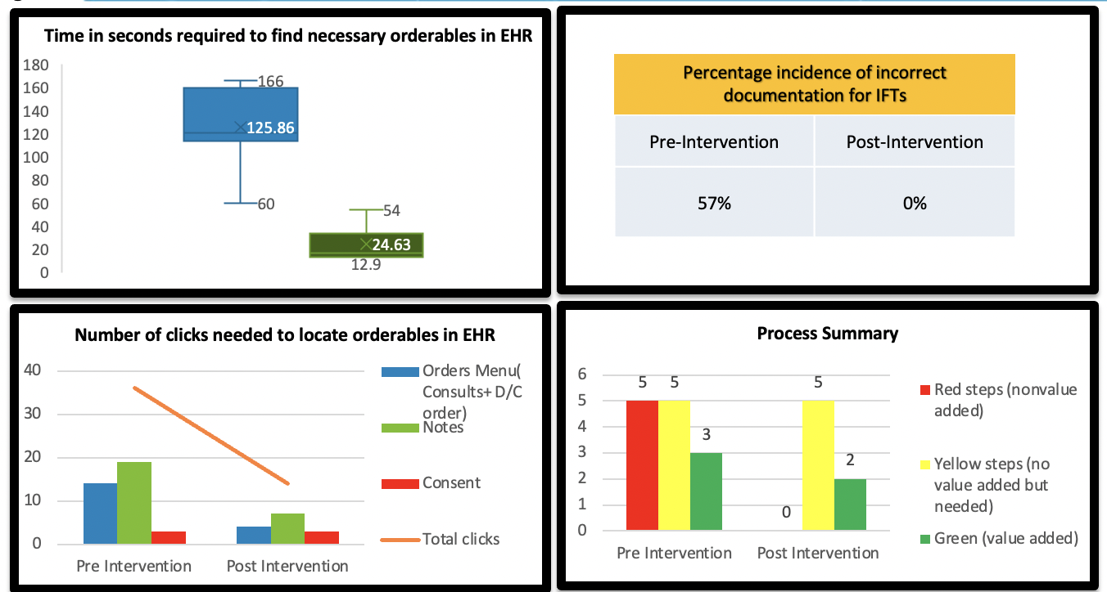
Figure 1. Differences Between Pre and Post Intervention states.

Conclusion
Dissatisfaction with EHR usability and barriers have been proven to cause end-user task completion delays due to more clicks, navigating several menus, and inconsistent processes.(4) IFT menu & order-set creation, enhanced clinician task performance, improved end-user experience, eliminated improper consult placement, and reduced IFT delays. Future analyses will evaluate the cost savings associated with decreased transfer delays and enhanced provider efficiency.
References:
1. Myers V, Nolan B. Delays to Initiate Interfacility Transfer for Patients Transported by a Critical Care Transport Organization. Air Med J. 2021;40(6):436-40.
2. Hernandez-Boussard T, Davies S, McDonald K, Wang NE. Interhospital Facility Transfers in the United States: A Nationwide Outcomes Study. J Patient Saf. 2017;13(4):187-91.
3. VHA Directive 1094 Inter-facility Transfer policy: Date of Issue: Jan 20.
4. Roman LC, Ancker JS, Johnson SB, Senathirajah Y. Navigation in the electronic health record: A review of the safety and usability literature. J Biomed Inform. 2017;67:69-79.

